Final evaluation for “INT. ELEVATOR – DAY” Group LP8

My role on this film was cinematographer/ camera operator, however as a small crew we each embraced a variety of roles. As this was a studio shoot, we simply used three flats as our elevator interior. Overall, this project was highly challenging and tested my creative and technical abilities. Throughout, I worked collaboratively with my team to bring the desired vision to screen. Within the camera department, we researched and developed how to light and shoot an elevator interior.

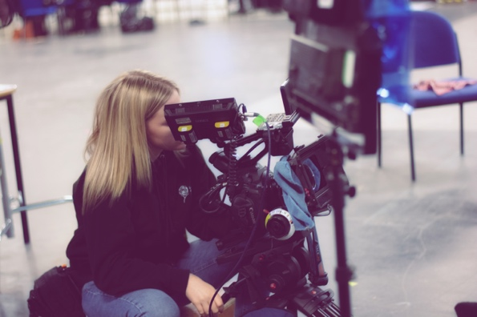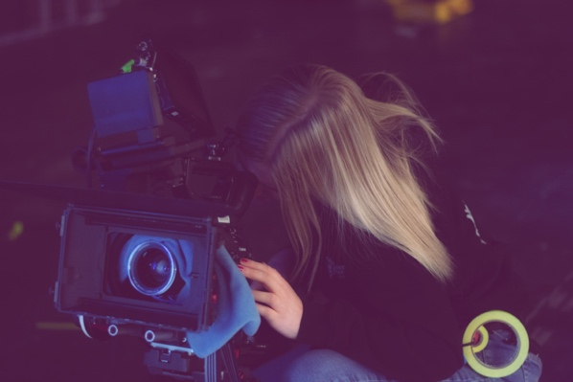

Through research, we established a top light was necessary. I was aware this can often be unflattering and cast harsh shadows under the eyes, nose and chin. We decided to use a Kino Flo overhead. Already a soft source and combined with grid meant light gently rolled off faces and softened shadows. Furthermore, it flagged off the top of the set which added depth and enhanced the look of an elevator. Overall, I feel this light source worked exceptionally well. Within my lighting plans, I added a silk to further soften the light. Although, this wasn’t necessary during production and I didn’t consider its placement well enough to execute it. Secondly, it meant I removed the value that elevator lightening often has sharp edges. I got wrapped up in keeping the light soft and flattering and not so much on the realism.

Additionally, it became apparent that to further achieve a believable space we needed to shoot from a low angle on a wide lens. The reason being, to avoid it looking flat. I then made the decision to shoot on a 35mm. I feel this enhanced the look well as it exaggerated the space of the lift but didn’t give any distortion to the faces. Additionally, the Canon 300 MI has a super 35mm sensor which ensured the shot wasn’t too wide. During pre-production, the team introduced the idea of adding an emergency light as the elevator breaks down. To represent the panic and physically show that the elevator has become stuck. This is one element I feel didn’t work as well as it could’ve. The initial plan was to drastically turn on an 800W with red gel and reduce two banks of the Kino during the breakdown. Even with diffusion the 800W was extremely strong, unflattering and took away the realism of the elevator that we were trying to achieve. As a result, we decided to simply flicker both the Kino and 800W briefly to replicate the disturbance of the breakdown. Furthermore, the brief introduced of red represents the panic and anger. This worked much better but not as successfully as it could've been. Overall, my improvements on the film would be how the emergency light was executed. If I was to reproach this element, I would use a Dedo light from a higher angle for a more subtle hint of red.

To conclude, I believe the final film is what I imagined it to be. In a creative context I feel everything has a meaning and flows well. The entire concept surrounds being stuck in a confined space and each time the scene rewinds, we get a flood of light as the elevator doors open again. To me this represents the script writer's creativity, he finds his light bulb moment briefly but then the light is gone, and he is taken back to square one and we get introduced to a new story.

